**Project Proposal Form**

1. **Title of the Project: Firewall Testing Tool.**
2. **Introduction of the Project - Problem Statement:**

**This software tool will be designed to help the IT auditors to test the firewall configurations and rules by parsing the text-based firewall configuration files.** **The tool should support testing three types of firewalls (including Juniper, Palo Alto and Huawei). The tool is should offer different functions for the auditor including, reading the configuration file, selecting the firewall type, selecting the needed tests and get storing the result in anther output file.**

1. **Objectives (Product Characteristics and Requirements):**

**Listed below are all the objectives that the system will try to attain:**

* **The program will be created by using VB.net.**
* **The program will be standalone.**

**No need to store any data in database and connect with the server.**

* **The program will be testing different firewall models (Juniper- Palo Alto- Huawei).**

**The software will give the user the ability to choose one of three firewalls by showing the user the interface with drop down list.**

* **The program should be able to read and parse the text-based configuration files of the supported firewall brands.**

**The software will give the user the ability to upload the configuration file to test it.**

* **The program should generate output reports for each tested firewall configuration file.**

**The user will be able to choose the output file name and location.**

* **The program should allow the user to select the test that he/she wants to perform.**

**The user will be able to select one or more test rule.**

1. **Interfaces:**

**This is a first prototype of the interfaces by using Axur software.**

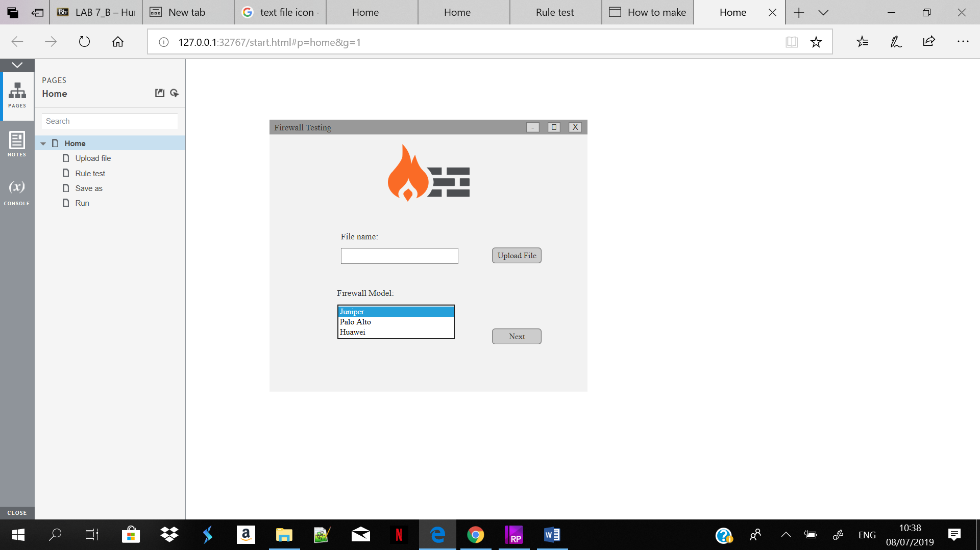

**This is the first interface will appear to the user when he/she open the software. The user should upload a file which want to be test it then choose from the drop-down list one if the firewall model.**

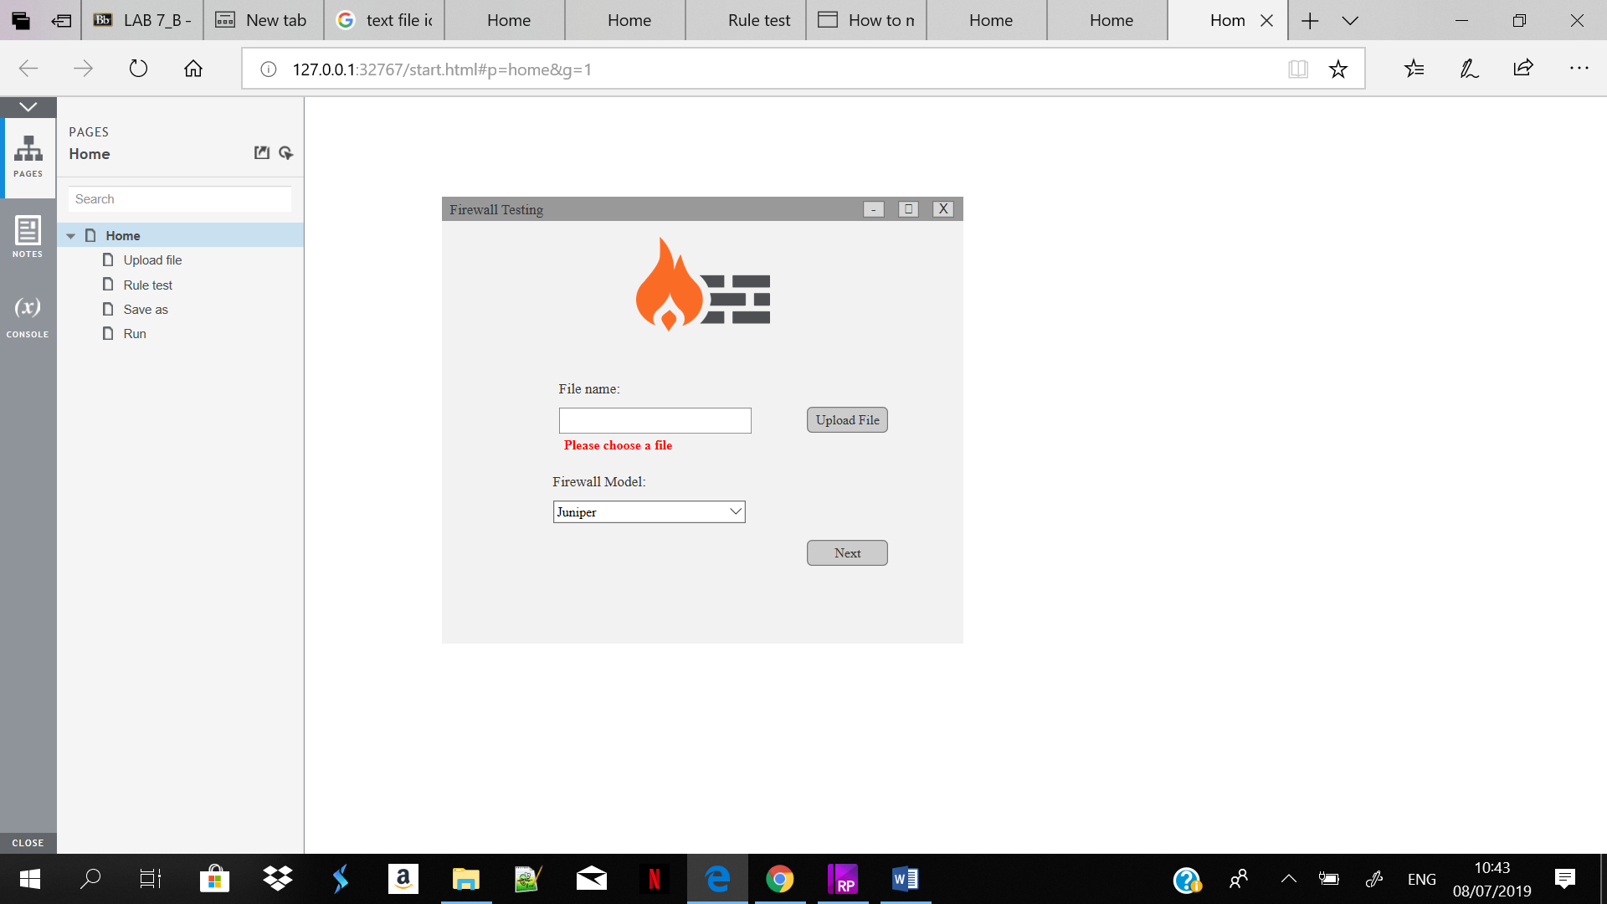

**If the user tries to go to the next interface by clicking on next button without fill the text field this error massage will appear.**

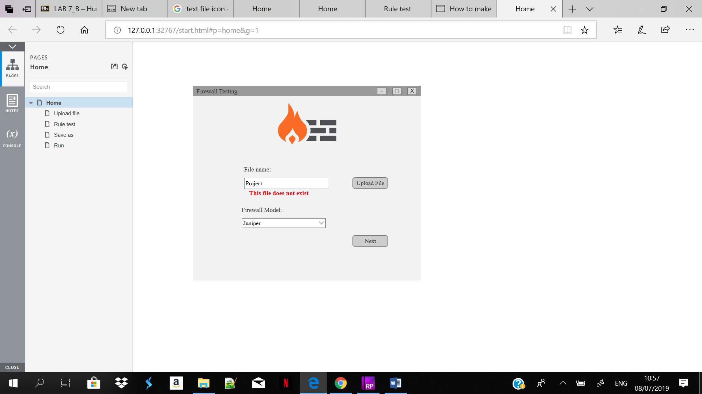

**If the user tries to write a file name and this file does not exist, then press next this error message will appear.**

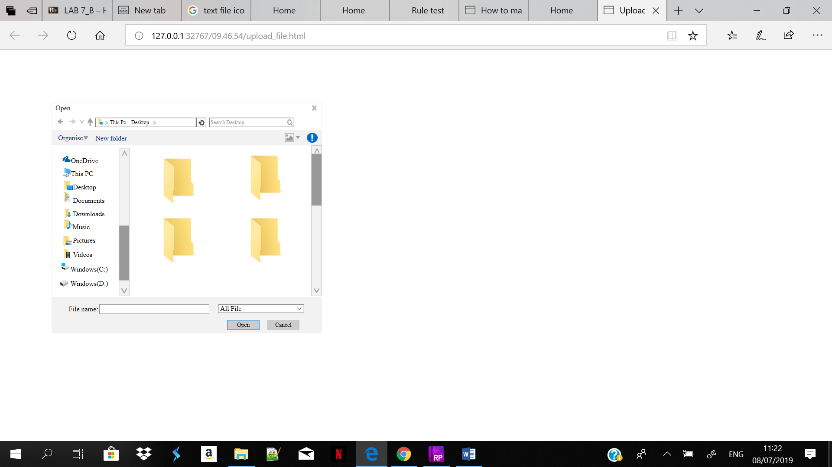

**When the user press on upload file button this interface will appear then the user will be able to choose which file he/she wants to test it.**

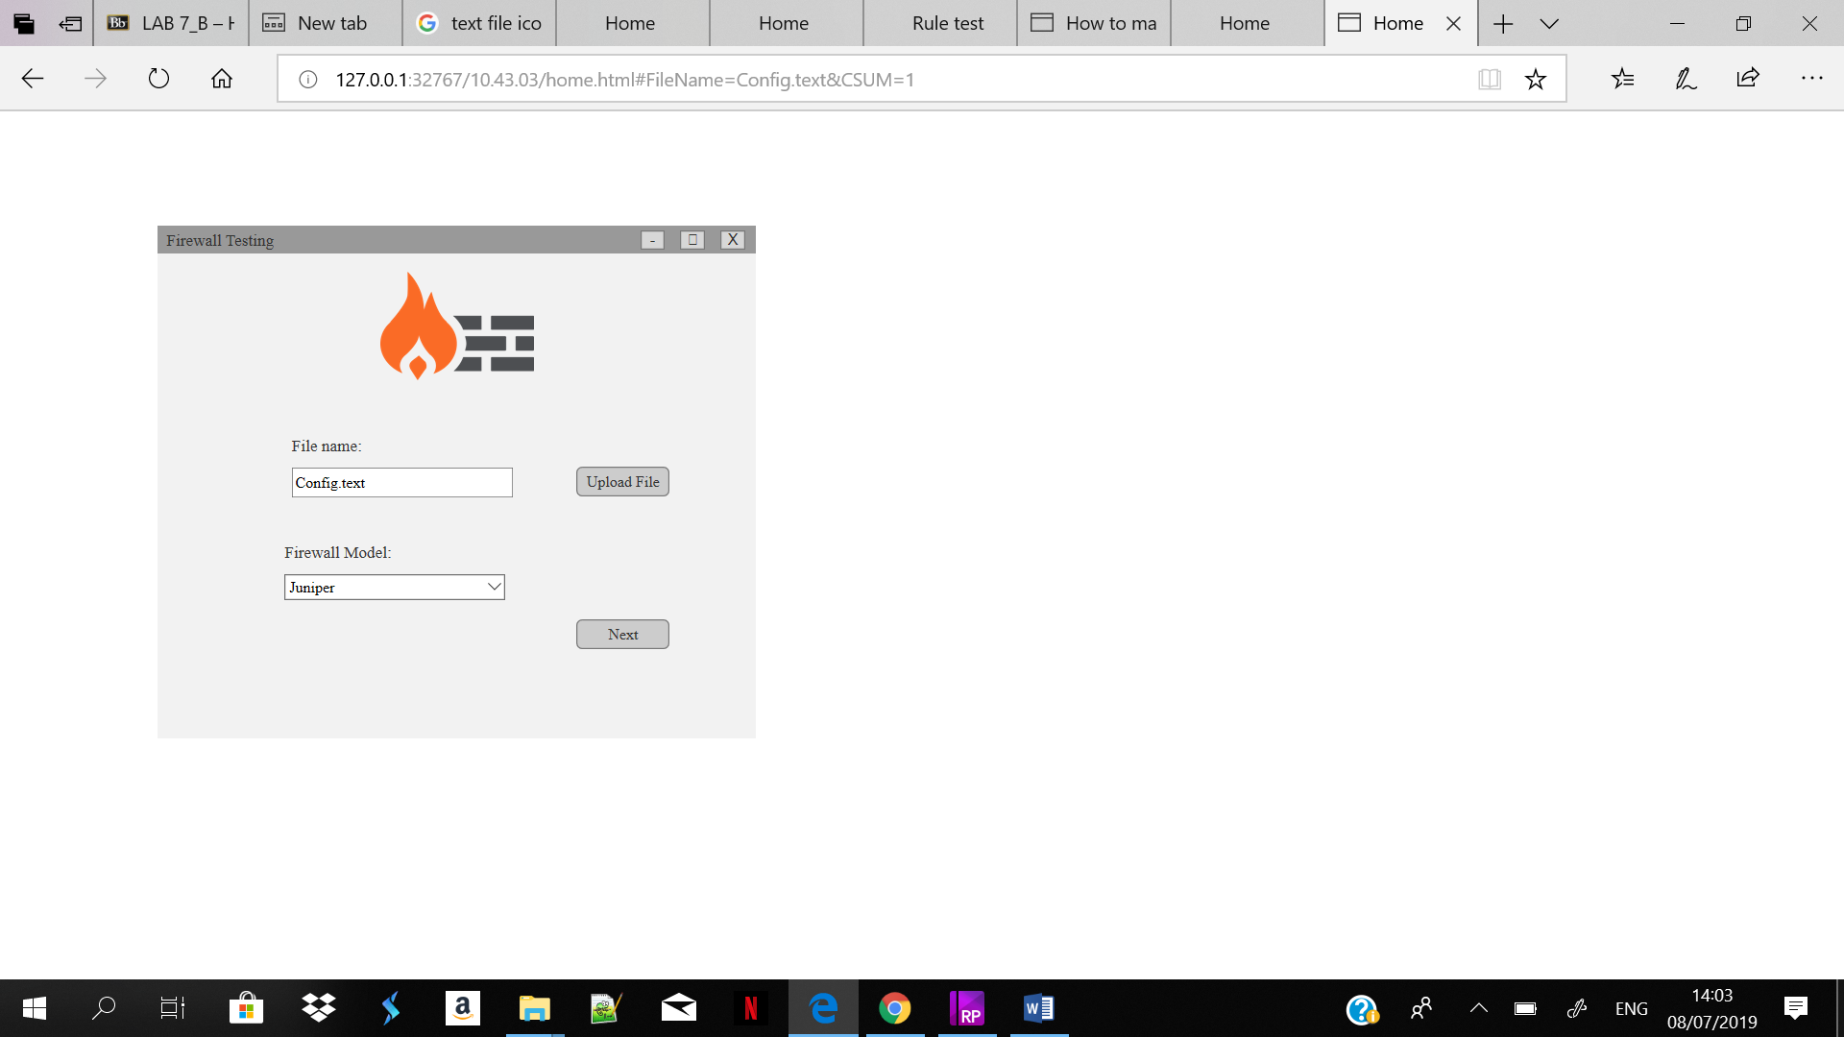

**This interface will appear after uploading the file then the user can press on next button to select the rules.**

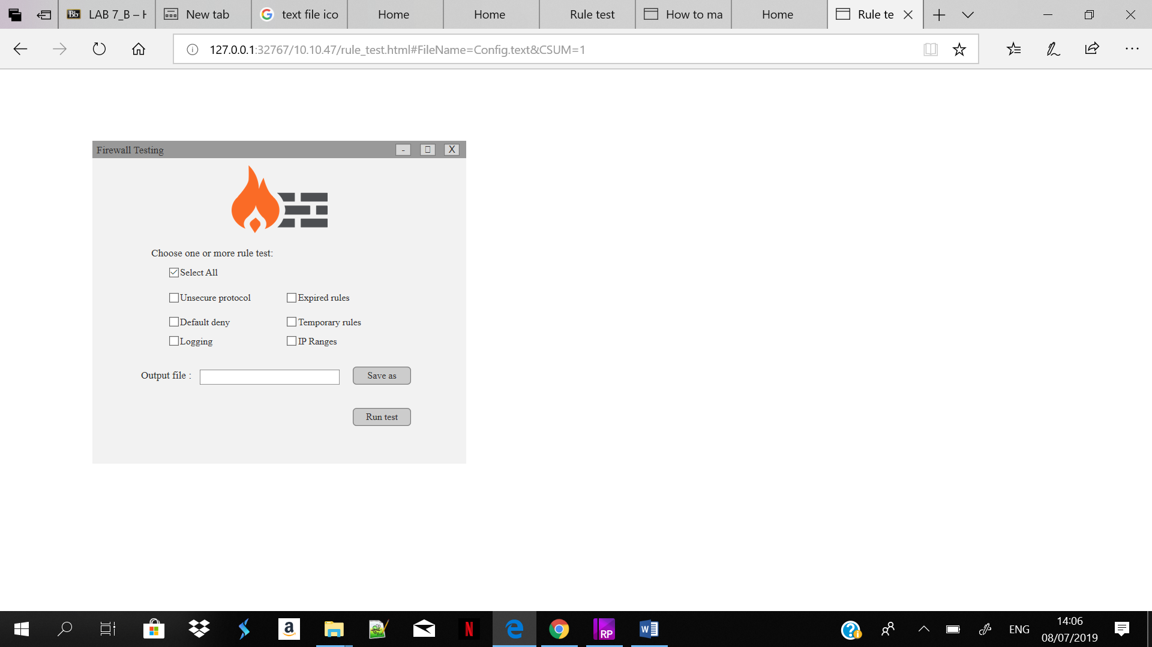

**This interface will appear after the user click on next button and from here the user can choose which rules need to test it then choosing the output file name and location.**

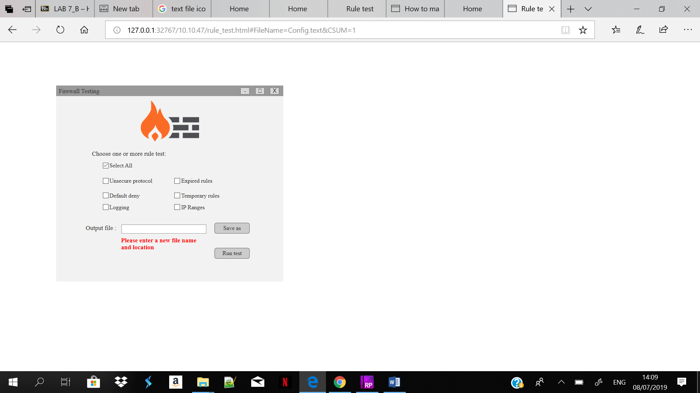

**If the user tries to click on Run test button without select the output file location or name this error message will appear.**

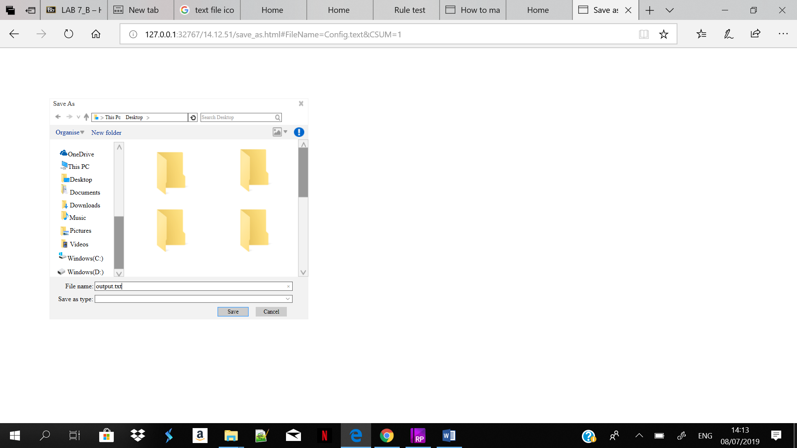

**This interface will appear after the user click save as button and from here the user can choose the location of output file and the name.**

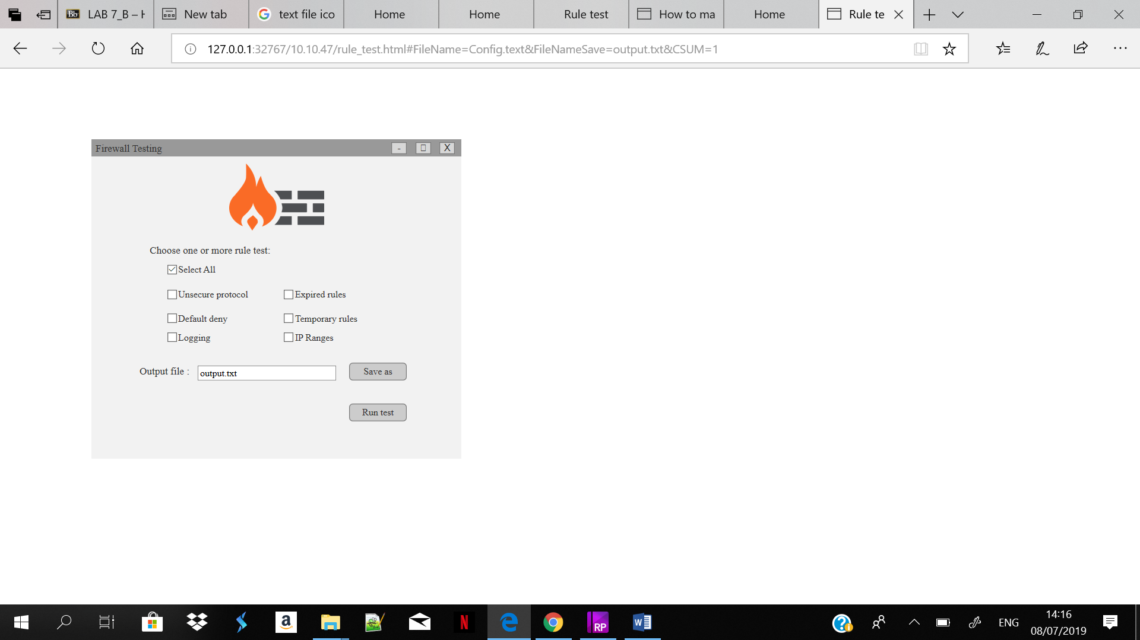

**After the user press on save button this interface will appear with output file name which the user chooses.**

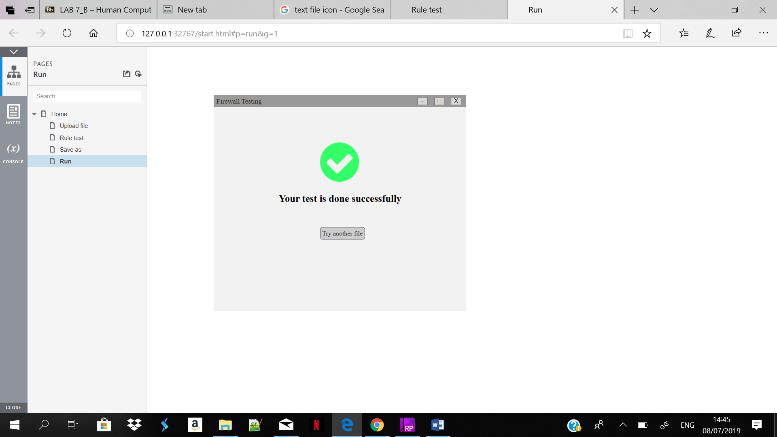

**This interface will appear after the user click on Run test button and the user will find the output file in the location he/she chooses. When the user clicks on Try another test button it takes the user back to the main interface.**

**----------------------------------------------------------------------------------------------------------------------------**

Approved Not approved Date: …………………….

Comments: